

PROJECT SYNOPSIS
OF
ONLINE RAILWAY RESERVATION AND MANAGEMENT SYSTEM

Submitted for the partial fulfillment of the requirement for
the degree of
Bachelor of Computer Applications (BCA)
Academic Session- 2023-2026
Department of Computer Applications

Submitted By:
SAAMARTH MINZ (7038)

Under the Guidance of
Ritesh Kumar Jha
Assistant Professor (CS & IT)
Netaji Subhas University Jamshedpur

ACKNOWLEDGEMENT
I would like to express my sincere gratitude and heartfelt appreciation to all those who have directly or indirectly contributed to the successful completion of my project titled “Online Railway Reservation and Management System”, submitted in partial fulfillment of the requirements for the award of the degree of Bachelor of Computer Applications (BCA) for the academic session 2023–2026.
First and foremost, I extend my deepest gratitude to my respected Project Guide, Mr. Ritesh Kumar Jha, for his invaluable guidance, continuous encouragement, constructive suggestions, and unwavering support throughout the development of this project. His profound knowledge, patience, and mentorship enabled me to clearly understand the project requirements and successfully complete the work within the stipulated time.
I would also like to express my sincere thanks to the Honourable Chancellor, Registrar, Dean, and Head of the Department (HOD) for their constant encouragement, administrative support, and academic guidance. Their vision and commitment to providing quality education created a motivating and enriching environment that greatly contributed to the successful completion of this project.
I am equally thankful to all the faculty members and staff of the Department of Computer Applications for their cooperation, valuable suggestions, and support during the course of this work.
Finally, I extend my heartfelt gratitude to my parents, family members, friends, and the management and staff of my internship organization for their continuous encouragement, moral support, and motivation throughout my academic journey. Their support has been instrumental in achieving this milestone.
I sincerely acknowledge and appreciate the contribution of everyone who assisted me in any way during the development of this project.
DECLARATION
I hereby declare that the project titled “Online Railway Reservation and Management System”, submitted in partial fulfillment of the requirements for the award of the degree of Bachelor of Computer Applications (BCA) for the academic session 2023–2026, is my original work carried out under the guidance of Mr. Ritesh Kumar Jha.
I confirm that this project has been completed independently and has not been submitted to any other university or institution for any degree, diploma, or certification. All sources of information have been properly acknowledged. I have adhered to all academic rules and ethical standards prescribed by the institution, and any assistance received has been duly acknowledged.
I understand that any act of plagiarism or academic misconduct may result in cancellation of the project and disciplinary action as per university rules.
Student Details:
- Name: SAAMARTH MINZ
- Registration Number: 7038
- Roll Number: 2303198
Signature:
Project Guide:
- Name: Mr. Ritesh Kumar Jha
- Signature:

Date: 10-04-2026 Place: Jamshedpur

INDEX

S.No | Contents | Page No.
1 | Acknowledgement
2 | Declaration
3 | Title of the Project
4 | Introduction
5 | Objectives of the Project
6 | Problem Statement
7 | Scope of the Project
8 | Methodology / Technology Used
9 | Hardware and Software Requirements
10 | Expected Outcome
11 | Conclusion
12 | Data Flow Diagram (DFD) – Level 0 (Context Diagram)
13 | Data Flow Diagram (DFD) – Level 1
14 | Data Flow Diagram (DFD) – Level 2 (If Required)
15 | ER Diagram (Entity Relationship Diagram)
16 | Entities, Attributes, and Relationships
17 | Database Structure
18 | References / Bibliography
19 | Internship Details
20 | Internship Certificate

TITLE OF THE PROJECT
ONLINE RAILWAY RESERVATION AND MANAGEMENT SYSTEM
Submitted in partial fulfillment of the requirements for the award of the degree of

Bachelor of Computer Applications (BCA)

Academic Session: 2023 – 2026
Submitted By

- Name: SAAMARTH MINZ
- Registration Number: 7038
- Roll Number: 2303198
Signature:

Course Details
Course Name: Bachelor of Computer Applications (BCA)
Semester: 6th Semester
Department: Computer Applications

Under the Guidance of
Guide Name: Ritesh Kumar Jha
Designation: Project Guide

Submitted To
Department of Computer Applications
NSU, Jamshedpur
Date: 10-04-2026 Place: Jamshedpur
INTRODUCTION

The Online Railway Reservation and Management System is a web-based application developed to automate and simplify the railway ticket booking process. In today’s digital era, users expect fast, reliable, and convenient services that reduce time and effort. With the increasing use of the internet and smartphones, online reservation systems have become essential.
Traditional railway reservation methods involve standing in long queues, manual ticket booking, and delays in processing. These methods are time-consuming and prone to human errors in data entry, ticket management, and record keeping. Such inefficiencies lead to inconvenience for passengers and difficulties in managing large volumes of data.
To overcome these challenges, the proposed system provides a user-friendly platform where users can register, log in, search for trains, check seat availability, and book tickets online. The system also allows administrators to manage train schedules, update information, monitor bookings, and maintain records in a structured database.
The application is developed using modern web technologies such as HTML, CSS, JavaScript, PHP, and MySQL, ensuring efficiency, reliability, and data security. It can be accessed from any device connected to the internet, making the booking process more flexible and accessible.
In the future, the system can be enhanced with features such as online payment integration, real-time tracking, and mobile application support. Overall, this project demonstrates the effective use of information technology in improving service quality and operational efficiency in railway reservation systems.

OBJECTIVES OF THE PROJECT

The main objective of the Online Railway Reservation and Management System project is to design and develop a computerized system that simplifies the process of railway ticket booking and improves the efficiency of railway operations. The system aims to provide a convenient, reliable, and user-friendly platform for passengers to book tickets and for administrators to manage train schedules and passenger data effectively.
The specific objectives of the project are as follows:
- To develop an online platform that allows users to book railway tickets easily from anywhere using the internet.
- To reduce manual work and paperwork involved in traditional railway reservation systems.
- To provide a user-friendly interface that ensures easy navigation for both passengers and administrators.
- To maintain accurate records of passengers, train schedules, bookings, and payments in a secure database system.
- To improve the speed and accuracy of ticket booking, cancellation, and confirmation processes.
- To enable administrators to manage train details, update schedules, and monitor bookings efficiently.
- To minimize errors in reservation handling and improve overall service quality.
- To ensure data security and confidentiality through proper authentication and authorization mechanisms.
- To generate reports related to bookings, revenue, and passenger details for better decision-making.
- To enhance customer satisfaction by providing fast, reliable, and convenient railway reservation services.
Overall, the project applies web and database technologies to improve railway reservation systems.
PROBLEM STATEMENT

In traditional railway reservation systems, passengers often face significant challenges such as long waiting queues at ticket counters, time-consuming booking procedures, and a lack of real-time information regarding train schedules and seat availability. These manual processes not only consume time but also increase the chances of human errors in ticket booking, cancellation, and record maintenance, leading to inconvenience and dissatisfaction among users.
Another major issue arises during peak booking periods, such as festivals, holidays, and Tatkal booking hours. During these times, the demand for tickets increases drastically, causing system overload, slow processing, booking failures, and server-related issues. As a result, users experience frustration due to unsuccessful transactions and unreliable booking services.
From the administrative perspective, managing large volumes of passenger data, train schedules, and booking records manually becomes extremely difficult. The absence of a centralized and automated system leads to poor data management, lack of proper tracking, and difficulty in generating accurate reports for decision-making. It also increases the risk of data inconsistency and security issues.
Furthermore, traditional systems do not provide sufficient transparency and flexibility for users to modify or cancel bookings easily. This limits user control and reduces overall efficiency in handling reservations.
Therefore, there is a strong need for a modern, reliable, and efficient Online Railway Reservation and Management System that can automate the entire process, provide real-time updates, ensure data security, reduce errors, and enhance the overall user experience for both passengers and administrators.

SCOPE OF THE PROJECT

The scope of the Online Railway Reservation and Management System defines the range of functionalities and features that the system will provide. The primary scope of this project is to develop a web-based application that enables passengers to book railway tickets online efficiently while allowing administrators to manage railway operations effectively.
The system covers essential functionalities such as user registration and authentication, searching for trains based on source and destination, checking real-time seat availability, fare details, ticket booking, and cancellation. It provides a user-friendly interface that ensures smooth interaction for passengers and simplifies the overall booking process.
From the administrative perspective, the system allows efficient management of train schedules, routes, seat availability, and passenger records. Administrators can update train details, monitor bookings, and maintain a structured database system for better data organization and retrieval.
Another important aspect of the scope is database management, where all information related to users, trains, bookings, and payments is stored securely. This ensures data consistency, quick access, and reliable system performance. The system also supports report generation, which helps in analyzing booking trends and improving decision-making.
The scope of this project is mainly limited to a web-based system developed using technologies such as HTML, CSS, JavaScript, PHP, and MySQL. It is designed to operate on a local server or small-scale environment.
However, in the future, the system can be extended with advanced features such as online payment gateway integration, mobile application support, real-time train tracking, and AI-based recommendations.

METHODOLOGY / TECHNOLOGY USED

The development of the Online Railway Reservation and Management System follows a structured and systematic approach to ensure efficiency, reliability, and accuracy. The project is developed using the Software Development Life Cycle (SDLC) model, which provides a step-by-step framework for building the system.

In the planning phase, the project requirements were identified, and
the objectives of the system were defined. The need for an automated
food ordering system was analysed based on the limitations of
traditional manual methods. In the analysis phase, detailed
information about user requirements, system functionalities, and data
processing needs was collected. During the design phase, system
architecture, database structure, and user interface layouts were
created using diagrams such as Data Flow Diagrams (DFD) and
Entity Relationship (ER) diagrams. The development phase involved
writing program code using appropriate programming languages and
tools to build the system features.

The testing phase ensures that the system functions correctly and
meets user expectations. Various types of testing, such as unit testing,
system testing, and user acceptance testing, were performed to
identify and fix errors or bugs in the system. After successful testing,
the system is implemented and made available for use by customers
and administrators. The final stage, maintenance, involves updating
the system, fixing issues, and improving performance as needed.

Technologies Used in the Project
Frontend Technologies
- HTML (HyperText Markup Language): Used to create the structure of web pages.
- CSS (Cascading Style Sheets): Used for designing and styling the user interface.
- JavaScript: Used to add interactivity, form validation, and dynamic behaviour.
Backend Technology
- PHP (Hypertext Preprocessor): Used for server-side scripting, handling user requests, and processing data.
Database
- MySQL: Used to store and manage data such as user details, train information, bookings, and payments.
Development Tools
- XAMPP: Provides a local server environment (Apache + MySQL).
- Visual Studio Code: Used for writing and managing code.
- Web Browser (Chrome/Edge): Used for testing and running the application.

Overall, the chosen methodology and technologies ensure that the system is scalable, efficient, secure, and capable of handling real-world railway reservation operations effectively.

HARDWARE AND SOFTWARE REQUIREMENTS

The successful development and execution of the Online Railway Reservation and Management System require appropriate hardware and software components to ensure smooth performance, reliability, and efficiency.
🔹 Hardware Requirements
- Processor: Intel Core i3 or higher
A capable processor is required to handle multiple operations such as running the server, database, and development tools simultaneously.
- RAM: Minimum 4 GB (Recommended: 8 GB)
Sufficient memory ensures smooth execution of the application and prevents system lag during development and testing.
- Storage: Minimum 500 GB Hard Disk / SSD
Required for storing project files, database records, software tools, and backups.
- Display Device: LCD/LED Monitor
Used for viewing code, system interface, and output.
- Input Devices: Keyboard and Mouse
Necessary for data entry, coding, and navigation.
- Network Connectivity: Internet / LAN
Required for accessing online resources, testing features, and simulating real-time operations.
- Printer (Optional):
Used for printing reports, tickets, or documentation if required.

🔹 Software Requirements
- Operating System: Windows 10 or higher
Provides the platform for running development tools and the application.

- Programming Languages:
  - HTML: For structuring web pages
  - CSS: For designing and layout
  - JavaScript: For interactivity and validation
  - PHP: For server-side processing
- Database Management System: MySQL
Used for storing and managing data such as user details, train information, bookings, and payments.
- Web Server: Apache (XAMPP)
Hosts the application locally and processes user requests.
- Web Browser: Google Chrome / Microsoft Edge / Mozilla Firefox
Used to access, test, and run the system interface.
- Development Tools:
  - Visual Studio Code: Code editor for writing and managing project files
  - phpMyAdmin: For database creation and management
  - XAMPP Control Panel: For managing Apache and MySQL services

Overall, these hardware and software requirements provide a stable environment for developing, testing, and executing the Online Railway Reservation and Management System efficiently.

EXPECTED OUTCOME

The Online Railway Reservation and Management System is expected to deliver an efficient, reliable, and user-friendly platform for booking railway tickets and managing reservations. The successful implementation of this system will significantly improve the overall experience for both passengers and administrators.
One of the primary outcomes of this project is the automation of the railway reservation process, which reduces manual effort and minimizes human errors in booking, cancellation, and record management. The system will provide real-time information about train schedules, seat availability, and booking status, ensuring transparency and accuracy.
The system is also expected to enhance operational efficiency by allowing administrators to manage train data, monitor bookings, and maintain passenger records in a structured database. This will improve data organization, enable faster processing, and support better decision-making through report generation.
Additionally, the project will ensure secure data handling by implementing authentication and authorization mechanisms, thereby protecting sensitive user information and maintaining system integrity.
From the user perspective, the system will offer convenience, speed, and accessibility, allowing passengers to book tickets anytime and from anywhere without the need to visit railway counters. This will lead to increased customer satisfaction and improved service quality.
Overall, the system is expected to demonstrate the practical application of web technologies in solving real-world problems and contribute to the modernization of railway reservation services.

CONCLUSION

The Online Railway Reservation and Management System has been successfully designed and developed to provide an efficient, secure, and user-friendly solution for modern railway ticket booking. The system replaces traditional manual processes with an automated platform that improves speed, accuracy, and reliability.
This project demonstrates the practical application of web development technologies and database management systems in solving real-world problems. It ensures effective management of train schedules, passenger data, and booking operations while reducing errors and operational complexity.
The system enhances user convenience by enabling passengers to access booking services anytime and anywhere, thereby improving overall customer satisfaction. At the same time, it provides administrators with better control, data organization, and reporting capabilities.
In the future, the system can be further enhanced by integrating features such as online payment gateways, real-time train tracking, mobile applications, and advanced analytics. These improvements will increase scalability and usability for large-scale deployment.
Overall, the project achieves its objectives and highlights the importance of digital solutions in improving efficiency and service quality in the railway reservation system.

DATA FLOW DIAGRAM (DFD) – LEVEL 0

The Data Flow Diagram (DFD) Level 0, also known as the Context Diagram, represents the overall structure of the Online Railway Reservation and Management System as a single process. It shows how the system interacts with external entities such as customers and administrators. This diagram provides a high-level view of the system and illustrates the flow of data between users and the system without showing internal processes in detail.

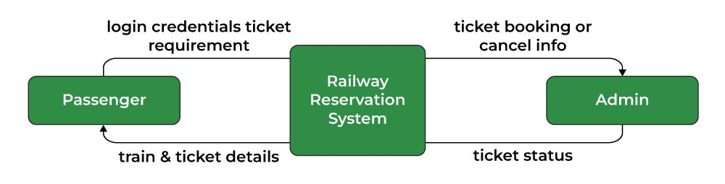
This process represents the entire system that handles all activities
related to Online Railway Reservation and Management System, including login credentials, ticket booking or cancel info, train & ticket details, and ticket status.

DATA FLOW DIAGRAM (DFD) – LEVEL 1
The Data Flow Diagram (DFD) Level 1 provides a detailed breakdown of the main process of the Online Railway Reservation and Management System into smaller sub-processes. It explains how data moves between different components of the system, including customers, administrators, and databases. This level shows the internal working of the system and how each function is performed step by step.

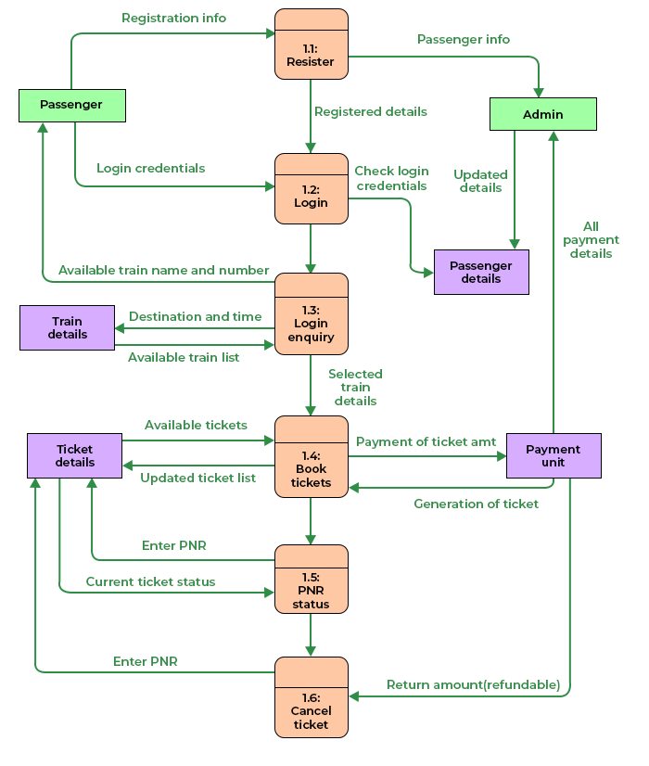

Data Flow Diagram (DFD) – Level 2

The Data Flow Diagram (DFD) Level 2 provides a more detailed view of the internal processes of the Online Railway Reservation and Management System. It breaks down each major process from Level 1 into smaller sub-processes to clearly show how data flows within the system. This level helps developers and users understand the step-by-step operations performed by the system.
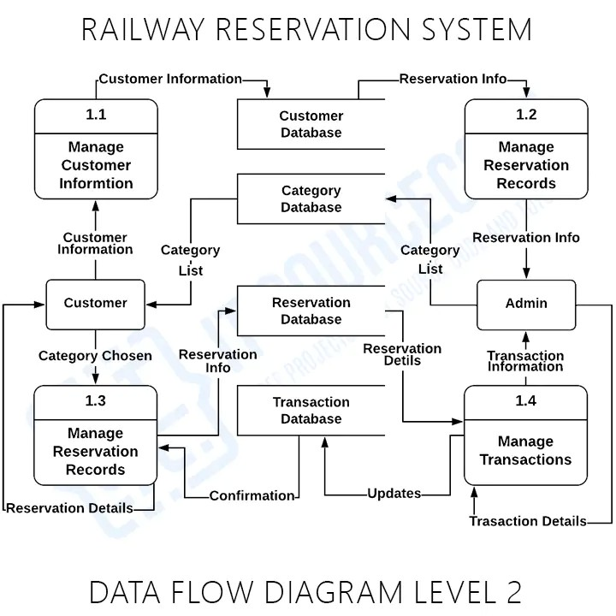

ER DIAGRAM (ENTITY RELATIONSHIP DIAGRAM)

The Entity Relationship (ER) Diagram of the Online Railway Reservation and Management System represent the logical structure of the database and illustrates how different entities are related to each other. The main entities in the system include User, Train, Booking, and Payment, which play a crucial role in managing the overall reservation process.

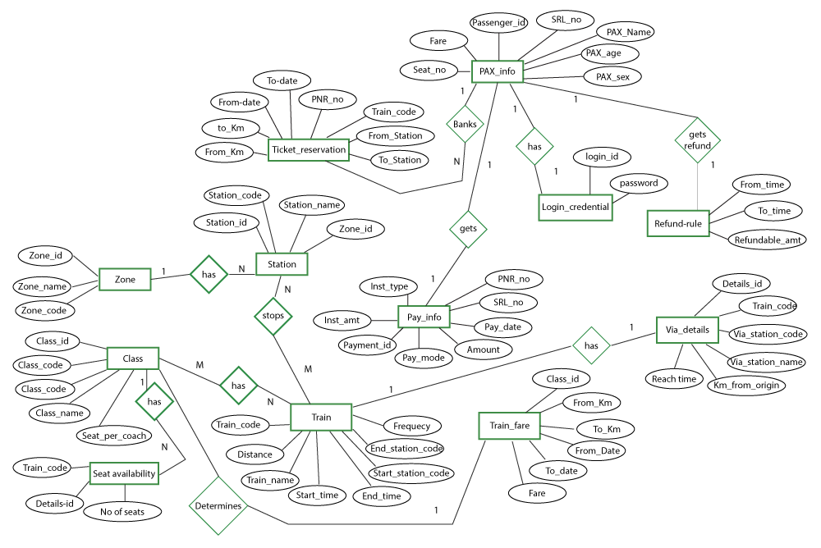
Overall, the ER diagram provides a clear and structured representation of the database design, which helps in efficient data storage, retrieval, and management in the railway reservation system.

Entities, Attributes, and Relationships
1. Entities
An entity represents a real-world object about which data is stored in the system. In the Online Railway Reservation and Management System, the main entities are:
- User
- Train
- Booking
- Payment

2. Attributes of Entities
Attributes define the properties or characteristics of each entity.
User
- UserID (Primary Key)
- Name
- Email
- Password
- Phone Number
Train
- TrainID (Primary Key)
- TrainName
- Source
- Destination
- Departure Time
- Arrival Time
Booking
- BookingID (Primary Key)
- UserID (Foreign Key)
- TrainID (Foreign Key)
- Booking Date
- Seat Number
- Status

Payment
- PaymentID (Primary Key)
- BookingID (Foreign Key)
- Amount
- Payment Date
- Payment Status

3. Relationships
Relationships define how entities are connected with each other in the system.
- A User can make multiple Bookings (One-to-Many relationship).
- Each Booking is associated with one Train (Many-to-One relationship).
- Each Booking generates one Payment (One-to-One relationship).
These relationships ensure proper data organization, reduce redundancy, and maintain data integrity within the system.

DATABASE STRUCTURE

The database structure defines the tables used in the system along
with their fields, data types, sizes, and key constraints. It ensures
proper data organization, storage, and retrieval for efficient system
performance.

1. USERS TABLE
Field Name | Data Type | Size | Key | Description
UserID | INT | 10 | Primary Key | Unique user ID
Name | VARCHAR | 100 |  | User full name
Email | VARCHAR | 100 | Unique | Email address
Password | VARCHAR | 50 |  | User password
PhoneNumber | VARCHAR | 15 |  | Contact number

2. TRAINS TABLE
Field Name | Data Type | Size | Key | Description
Train ID | INT | 10 | Primary key | Unique train ID
Train Name | VARCHAR | 100 |  | Train name
Source | VARCHAR | 50 |  | Starting station
Destination | VARCHAR | 50 |  | Ending Station
Departure Time | TIME | - |  | Departure time
Arrival time | TIME | - |  | Arrival time
Available Seats | INT | 5 |  | Total seats available

3. BOOKINGS TABLE
Field Name | Data Type | Size | Key | Description
Booking ID | INT | 10 | Primary Key | Unique booking ID
User ID | INT | 10 | Foreign Key | References Users
Train ID | INT | 10 | Foreign Key | References Users
Booking Date | DATE TIME | - |  | Date of boooking
Seat Number | VARCHAR | 10 |  | Seat number
Status | VARCHAR | 20 |  | Confirmed / Cancelled

4. PAYMENTS TABLE
Field Name | Data Type | Size | Key | Description
PaymentID | INT | 10 | Primary Key | Unique payment ID
BookingID | INT | 10 | Foreign Key | References Bookings
Amount | DECIMAL | 10,2 |  | Payment amount
PaymentDate | DATETIME | - |  | Payment date
PaymentStatus | VARCHAR | 20 |  | Paid / Pending

5.ADMIN TABLE
Field Name | Data Type | Size | Key | Description
AdminID | INT | 10 | Primary Key | Unique admin ID
AdminName | VARCHAR | 100 |  | Admin name
Email | VARCHAR | 100 |  | Admin email
Password | VARCHAR | 50 |  | Login password

6.TRAIN SCHEDULE TABLE
Field Name | Data Type | Size | Key | Description
ScheduleID | INT | 10 | Primary Key | Unique schedule ID
TrainID | INT | 10 | Foreign Key | References Trains
Date | DATE | — |  | Travel date
AvailableSeats | INT | 5 |  | Seats available on date

There is total 6 tables in Online Railway Reservation and Management System,
  - USERS
  - TRAINS
  - BOOKINGS
  - PAYMENTS
  - ADMIN
  - TRAIN SCHEDULE

Primary Keys ensure unique identification of records, while Foreign Keys maintain relationships between tables.

REFERENCES / BIBLIOGRAPHY

The successful completion of the Online Railway Reservation and Management System, project was made possible with the help of various books, websites, and online resources. These references provided valuable knowledge about programming, database management, web development, and system design concepts used in developing this project.

Websites:
  - www.geeksforgeeks.org
  - www.chatgpt.com

These references were used to understand system development
concepts, database design, programming techniques, and
implementation methods required to successfully design and develop
the Online Railway Reservation and Management System.

INTERNSHIP DETAILS

Company Name - ARDENT COMPUTECH PVT.LTD.
Company Address - MODULE 103, SDF BUILDING, SECTOR V, SALT LAKE, KOLKATA - 700091
Email __________________________
Contact Number __________________________
Duration of
Internship
45 Days / 6 Weeks

Internship Start
Date - 10 September 2025

Internship End
Date - 15 November 2025

Supervisor Name __________________________
Supervisor
Designation

__________________________

Contact

Nature of Work / Training Details – Data Science, Artificial Intelligence and Machine Learning Using Python

